Data Structures and Algorithms Lab
Assignment 4
Experiment 4: To demonstrate the use of arrays and linked lists to implement different variants of Queue and its applications.

Instruction: Make a pdf file of the program code in C and its output.
Name: Aditi Srivastava
SAP ID: 590026127
Batch: 39
Link of your GitHub Account:
Course: B.Tech. CSE (Sem II)
Subject: DSA Lab
Date: 24 March 2026
Note: Do all the implementations in C programming.
- Write a C program to implement a Queue data structure using an array. The program should be modular and use separate functions for each operation.
- Insert (Enqueue): Add an element to the Queue.
- Delete (Dequeue): Remove an element from the Queue.
- Display: Display all elements of the Queue.
- Peek: Display the front element of the Queue.
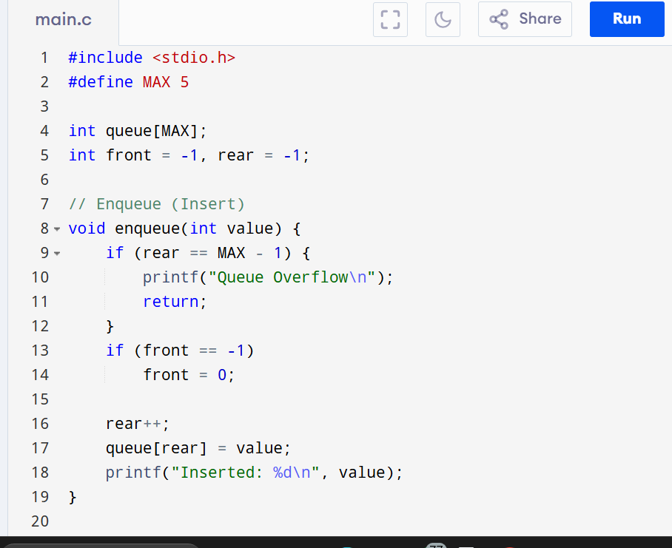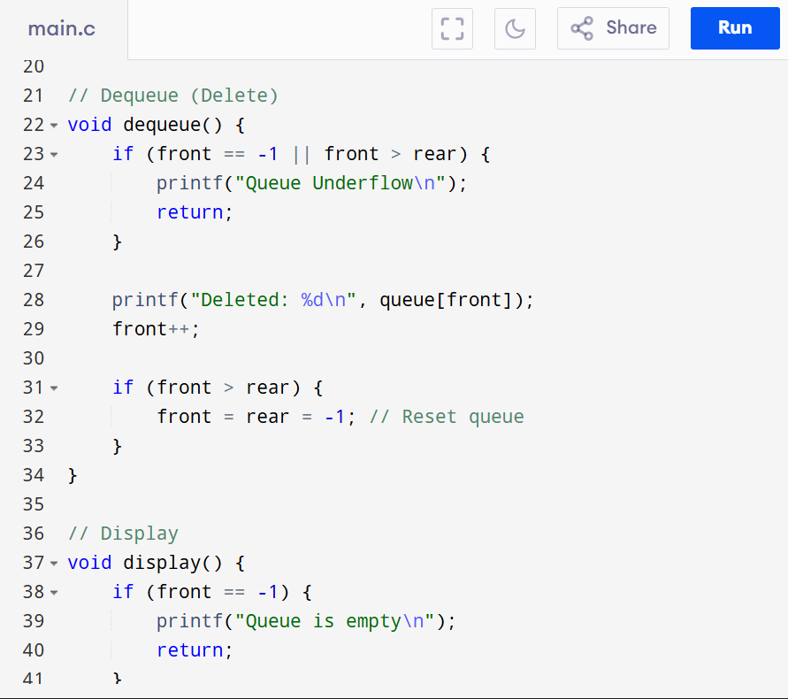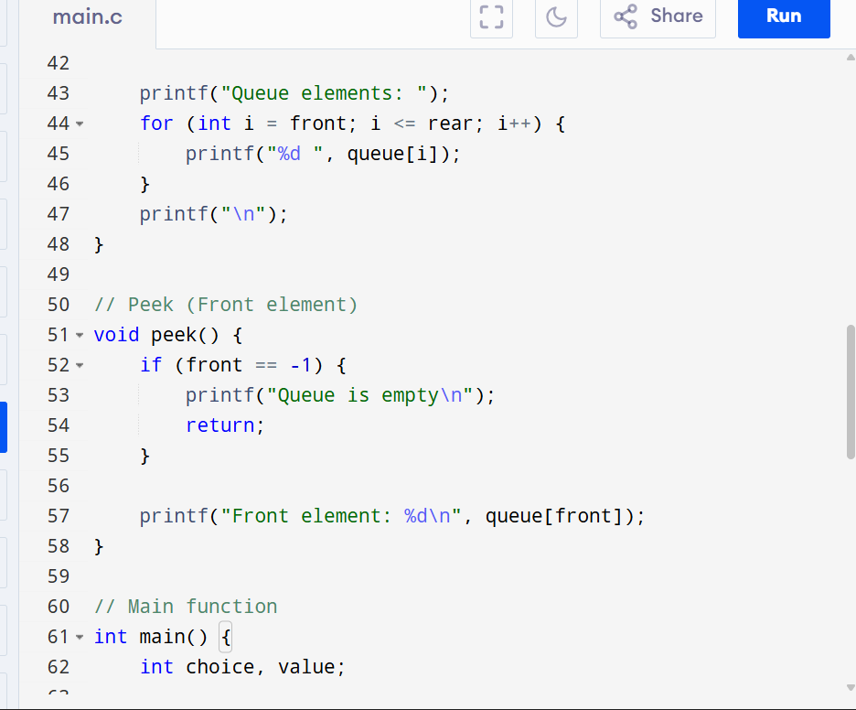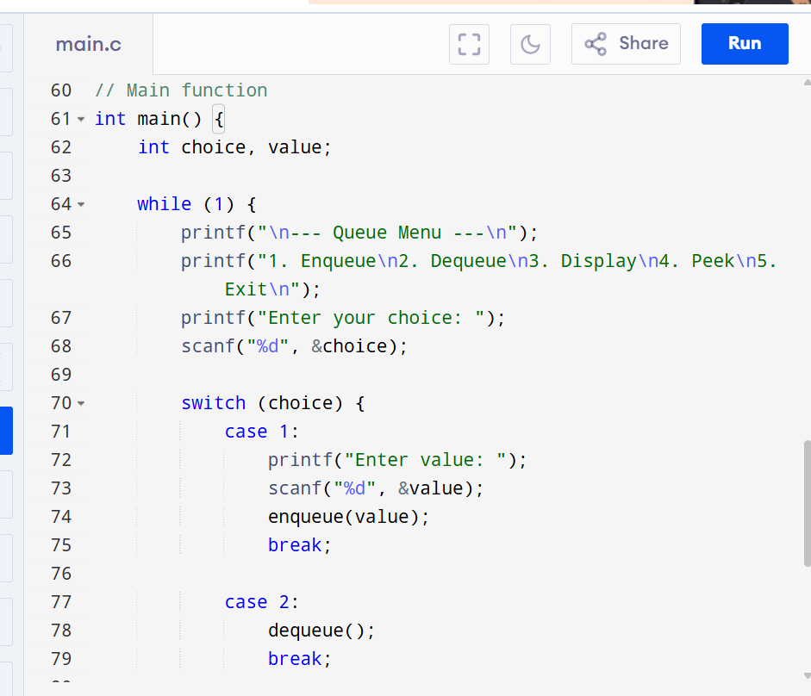
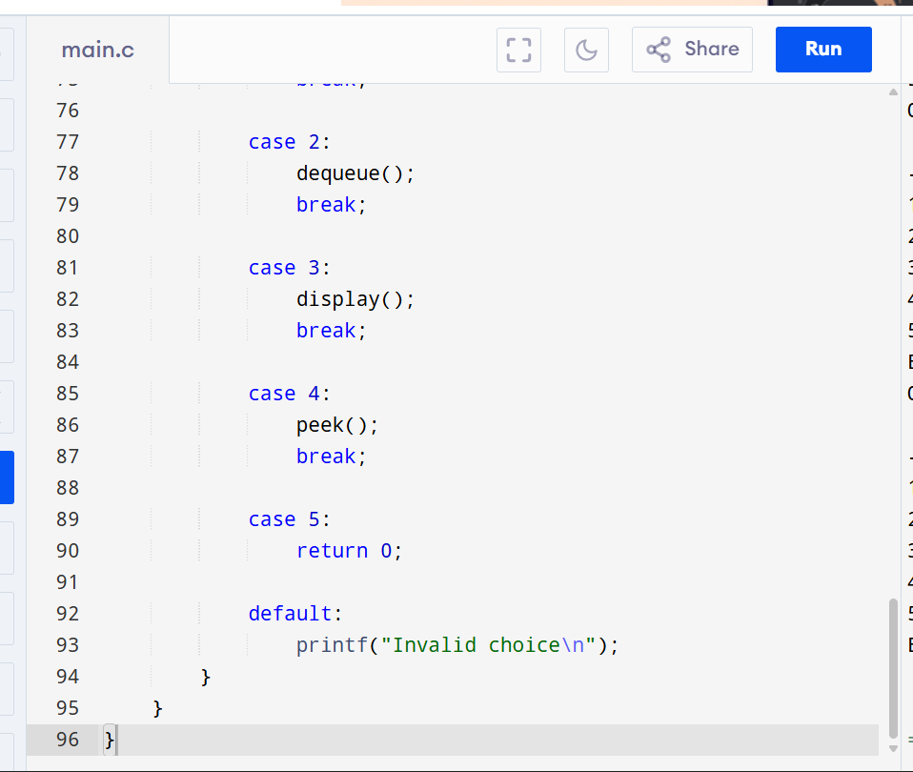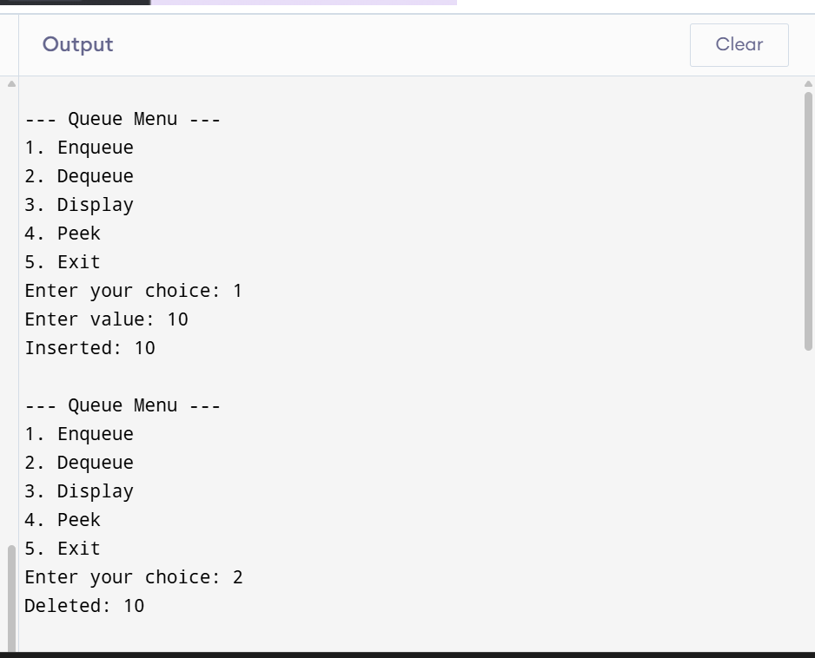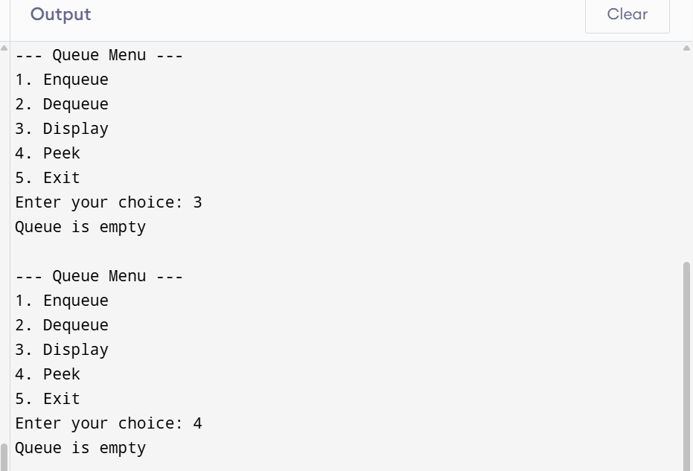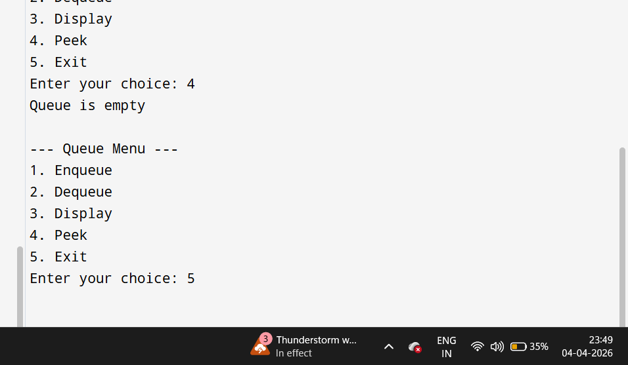
- Write a C program to implement a Queue using a Linked List. The program should support the following operations using separate functions:
- Enqueue (Insert): Insert an element into the Queue.
- Dequeue (Delete): Remove an element from the Queue.
- Display: Display all elements of the Queue.
- Peek: Display the front element of the Queue.
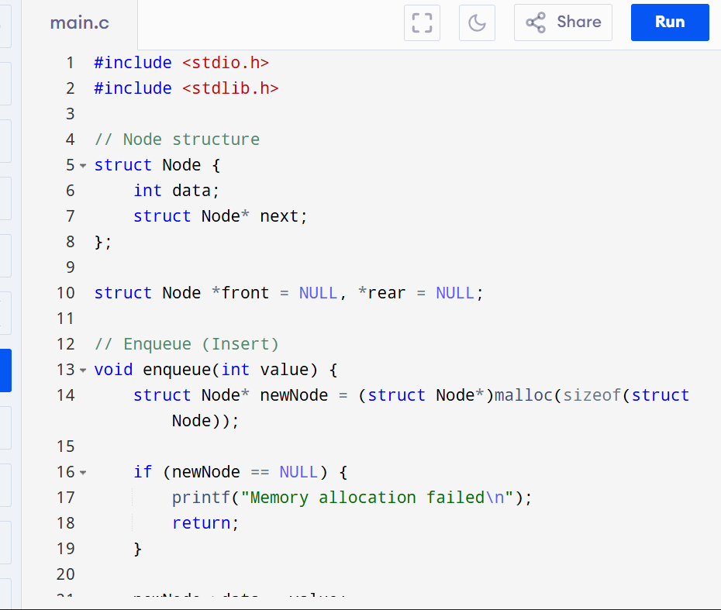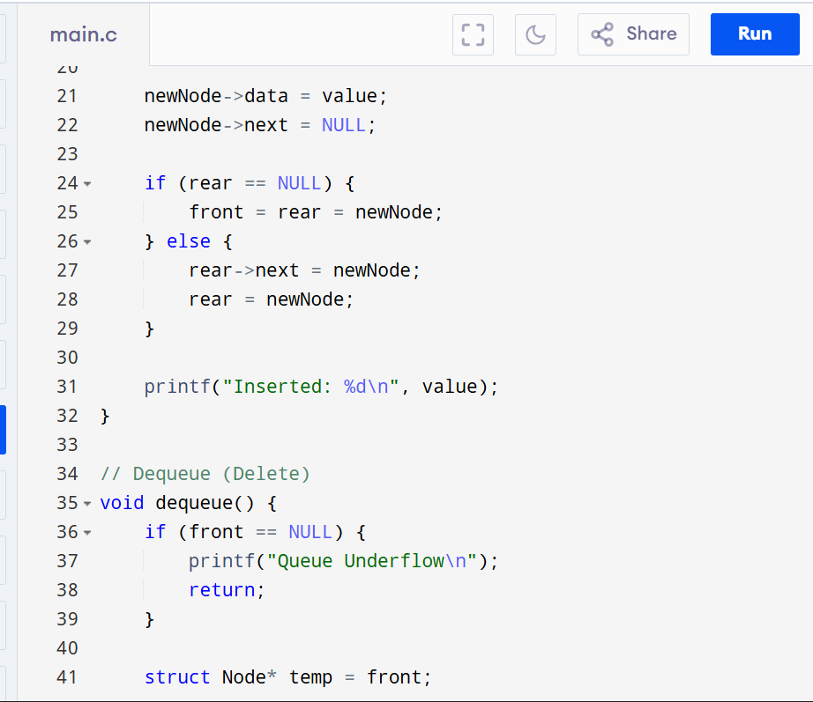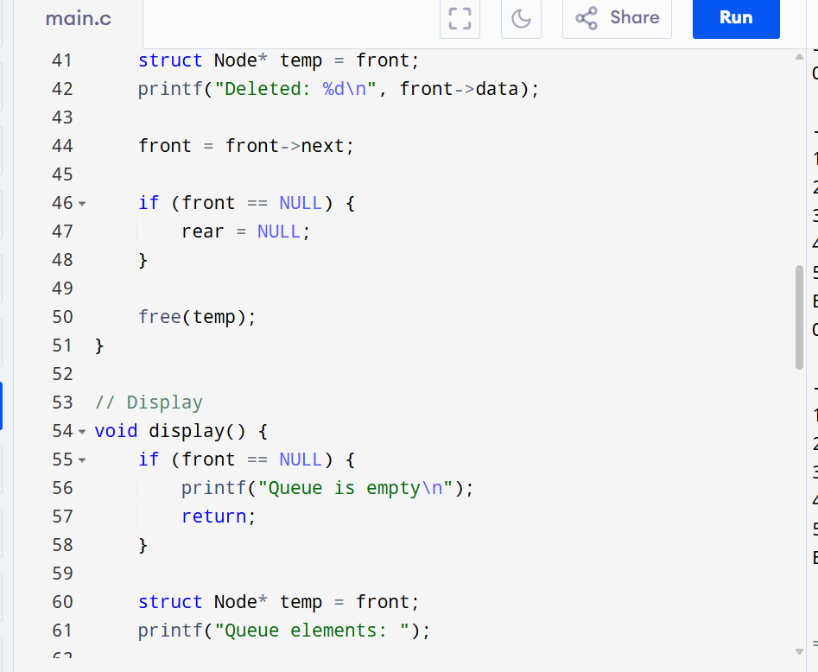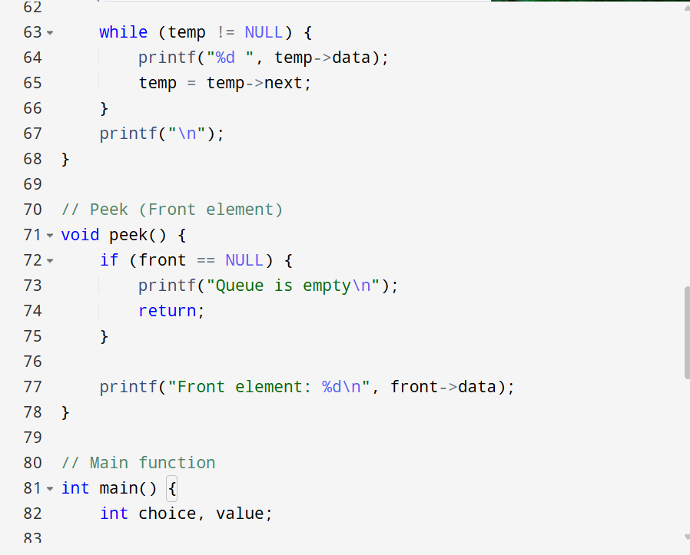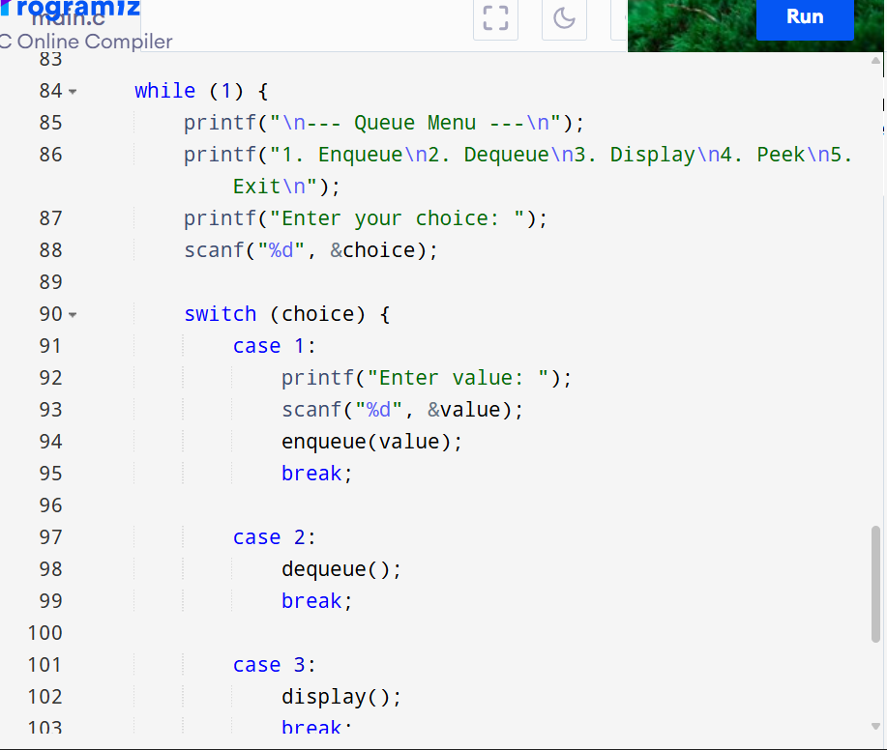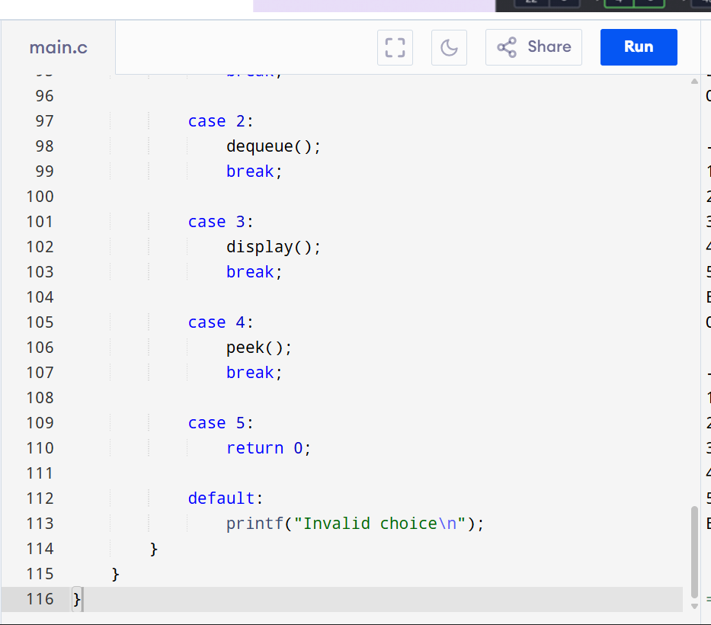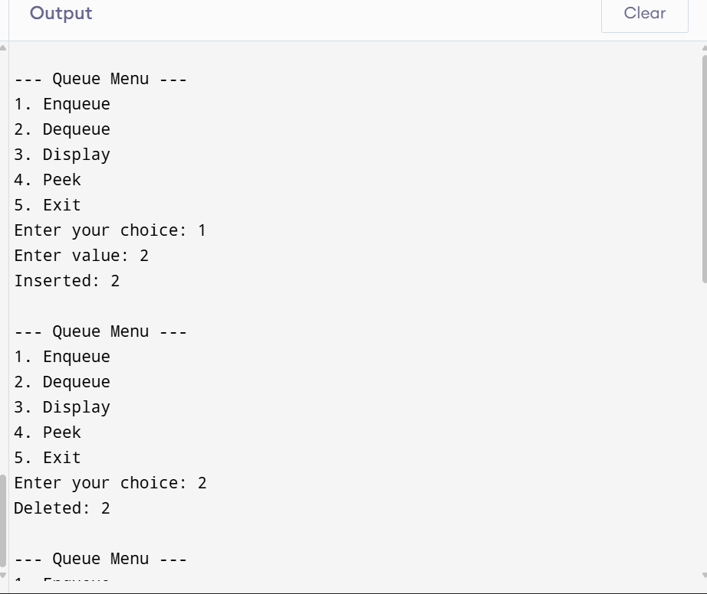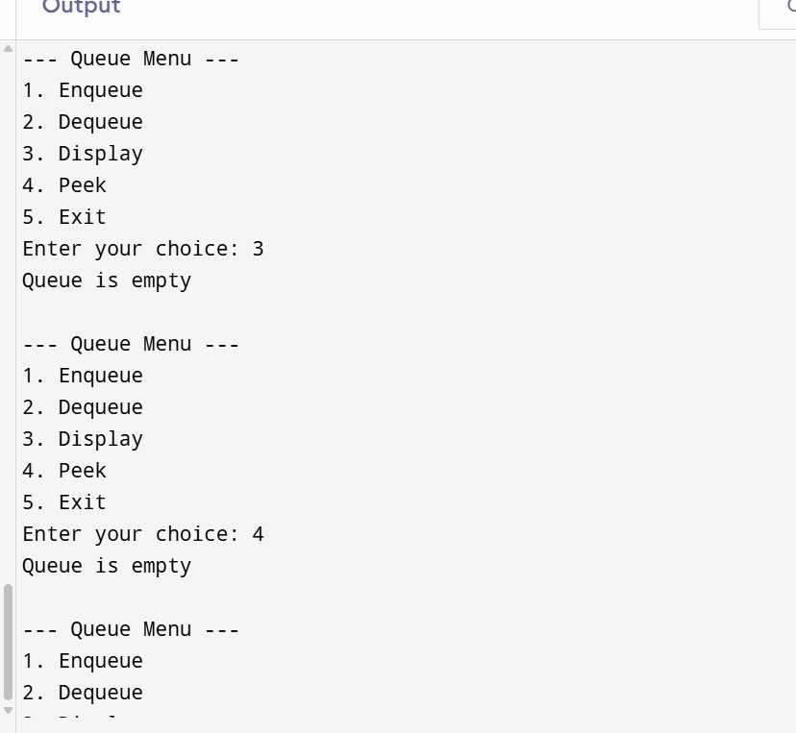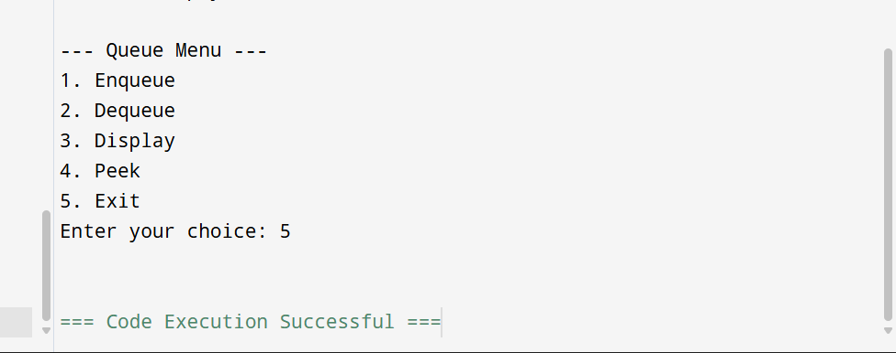
- Write a program to check whether a given string is a palindrome or not using an Array and a Queue data structure.
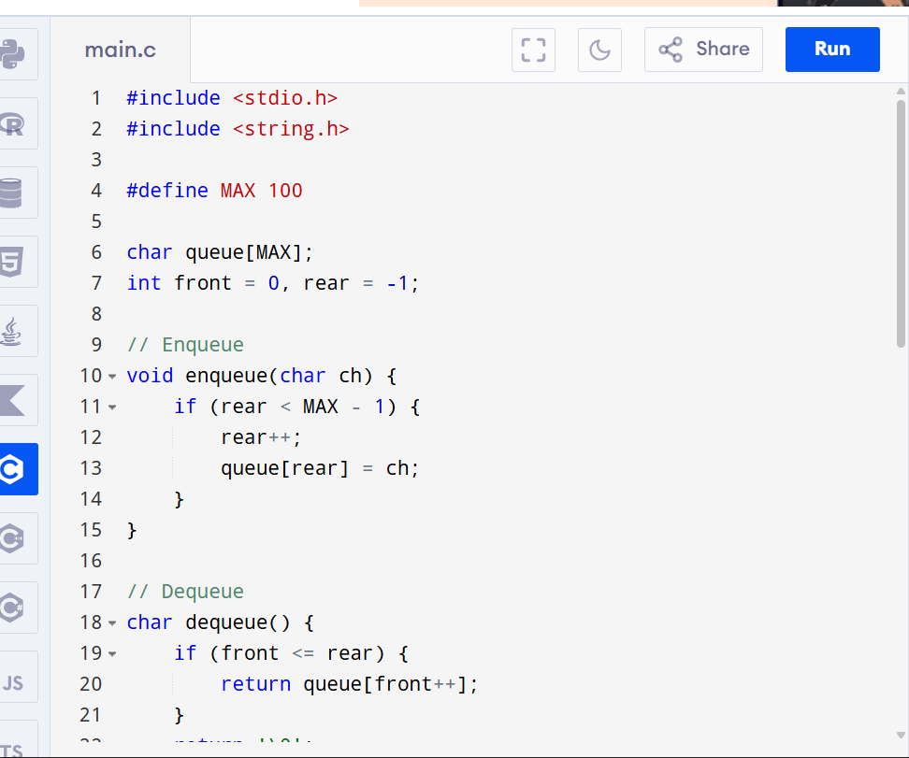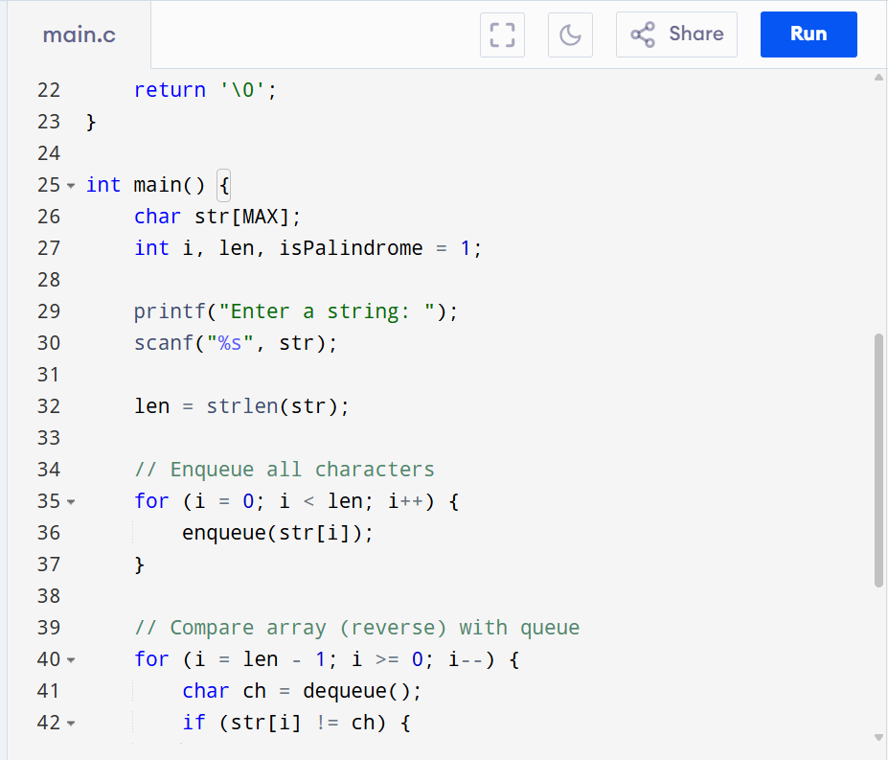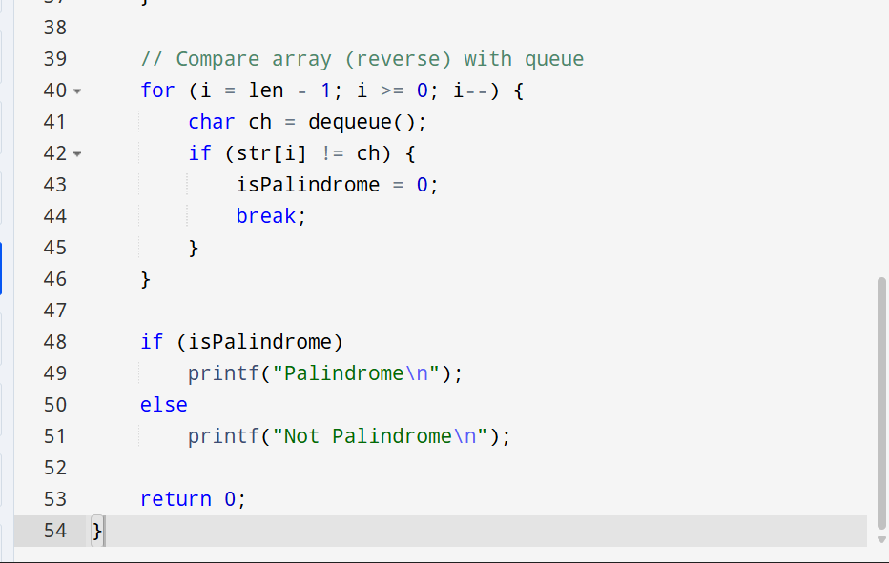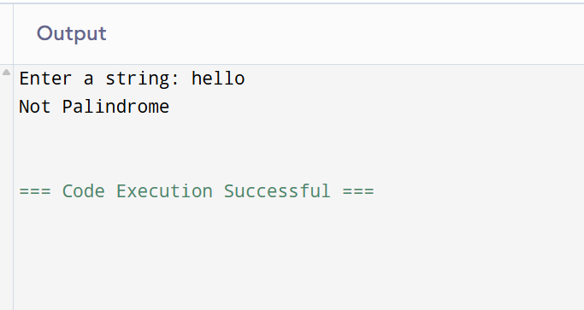

- Write a C program to implement a Circular Queue using an array of fixed size using the following functions for each operation.
- Insert (Enqueue): Add an element to the Circular Queue.
- Delete (Dequeue): Remove an element from the Circular Queue.
- Display: Display all elements of the Circular Queue.
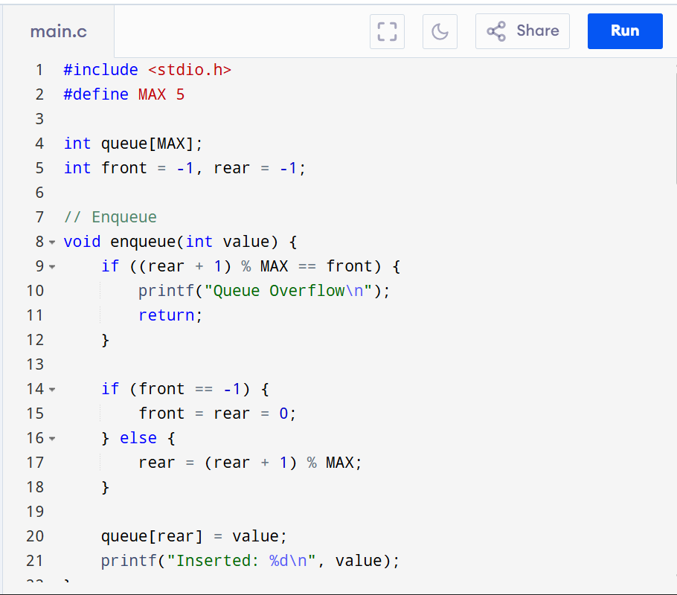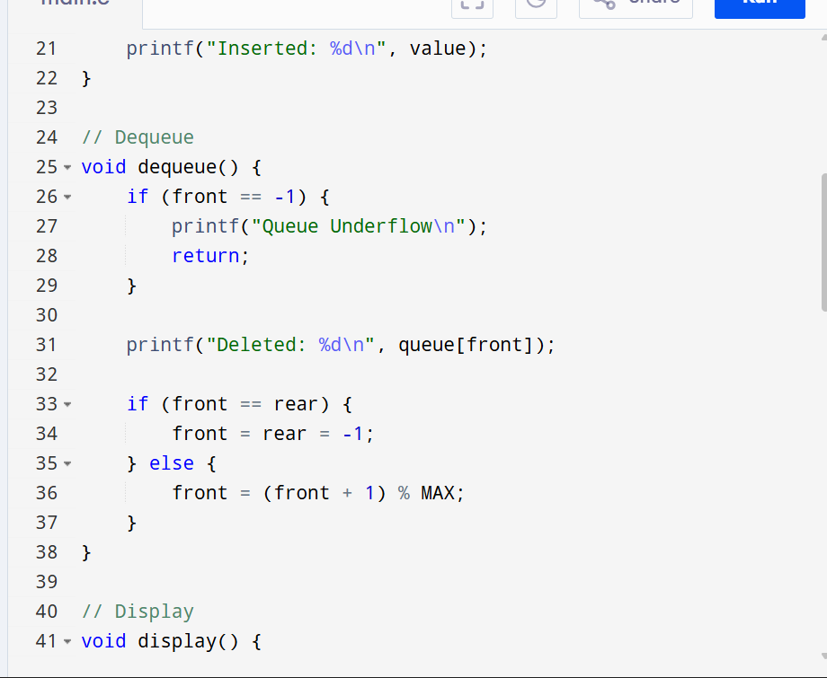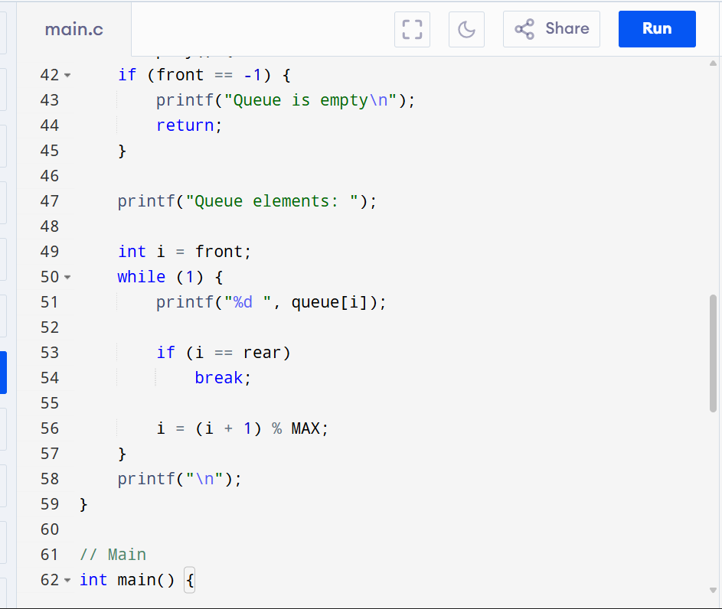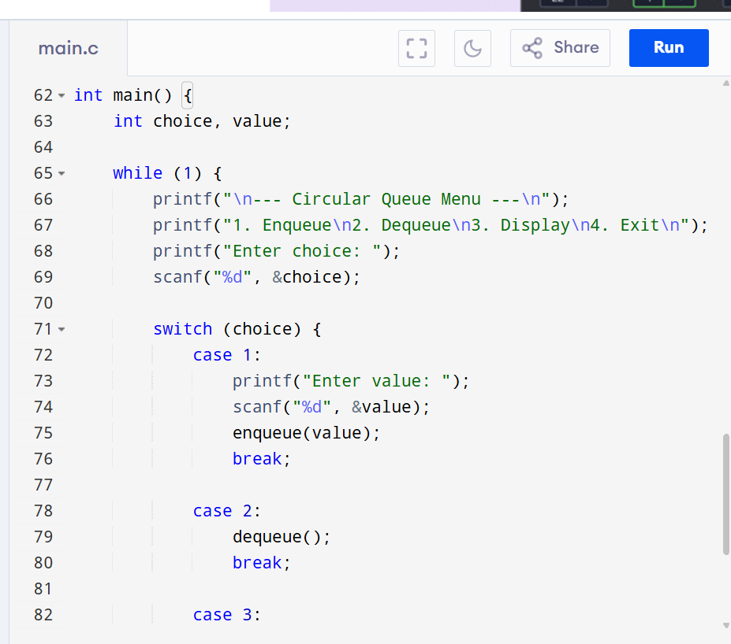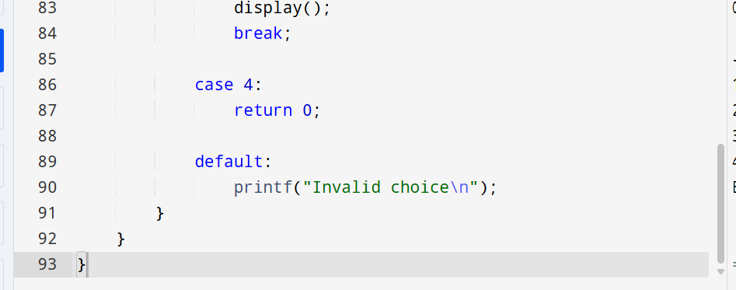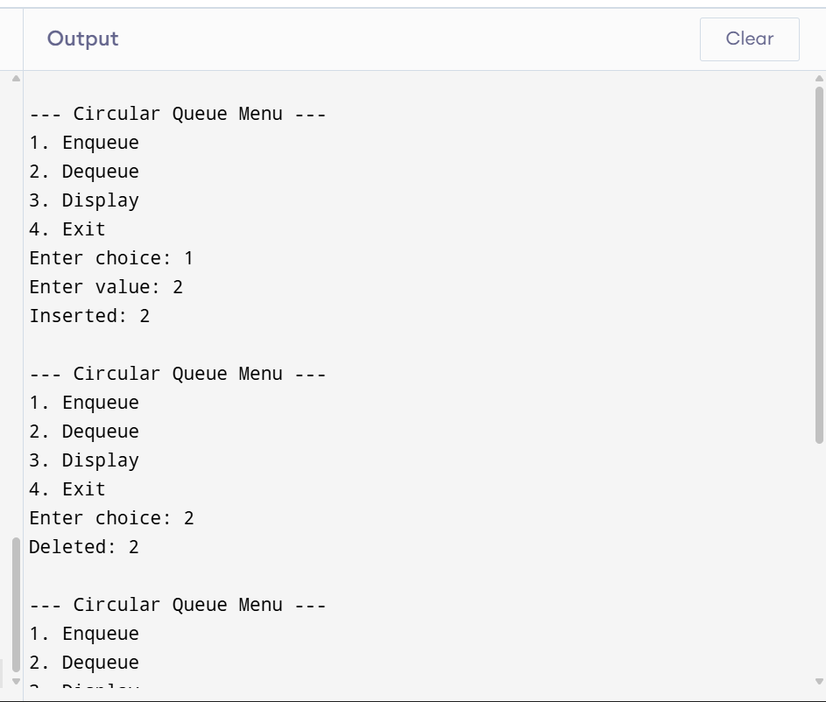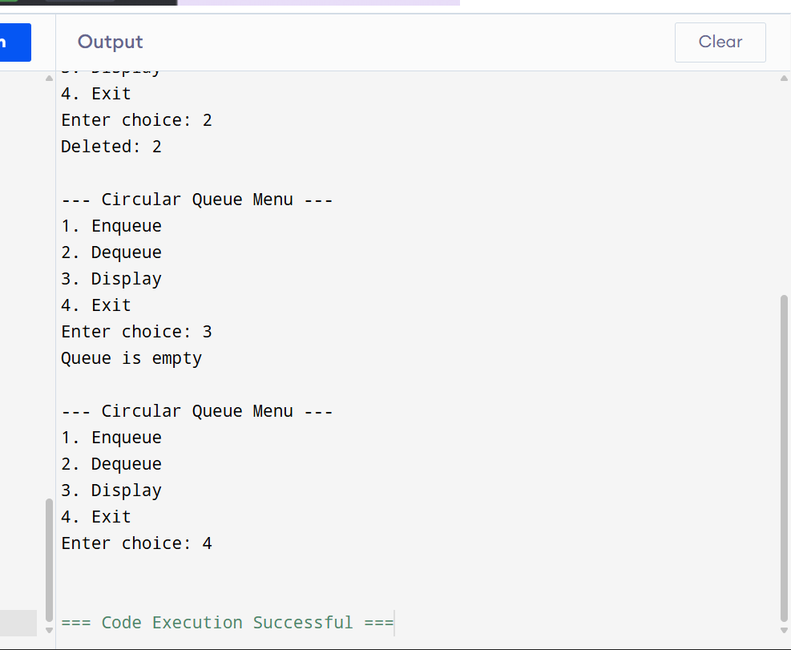
- Write a C program to implement a Stack using two Queues. The queues must be implemented using arrays, and all operations should be performed using functions.
- Push: Insert an element into the stack.
- Pop: Remove the top element from the stack.
- Peek: Display the top element without removing it.
- isEmpty: Check whether the stack is empty.
- Display: Print all elements of the stack.
